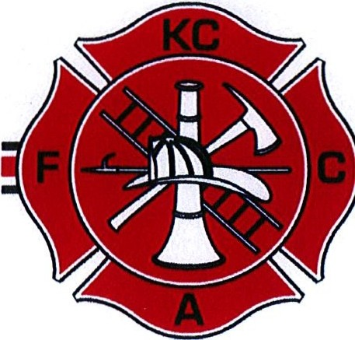
KITSAP COUNTY
FIRE COMMISSIONERS ASSOCIATION

Public Meeting Notice

KITSAP COUNTY
FIRE COMMISSIONERS ASSOCIATION
Monthly Meeting & Annual Picnic

July 15, 2017 at 5:00 pm

958 NW Norfinn Lane
Poulsbo, WA
